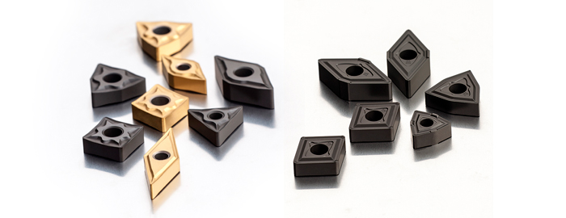

Our new range of inserts with positive NF geometry is for turning of stainless steel.
The inserts feature a number of benefits including:
- The double-sided inserts are available for finishing to medium turning of stainless steel, low carbon steel and super alloys.
- More than 110 variations in insert shapes (C, D, S, T, V and W), sizes and grades.
- The balanced shape of the chipbreaker provides a stable and sharp cutting edge, with a large area for chip formation and evacuation from the cutting zone.
- Its positive geometry allows for low cutting forces and minimises vibration occurring.
- Offers durability and reliability, enabling good productivity and a quality machined surface finish for the end user.
- Suitable to companies performing general turning applications, thanks to the low values of radial cutting force, making it suitable for unstable machining.

We also have new wiper inserts for turning with W-MR geometry. Key features include:
- Available in CNMG12, DNMG15 and WNMG06 and 08 inserts
- Suitable for longitudinal and face turning of steel, stainless steel and cast iron.
- The double-sided inserts have a positive chipbreaker and a new shape on the smoothing edge to achieve low roughness in turning.
- Offers reduced cutting forces and higher feeds, increasing productivity while retaining the same surface finish as with standard inserts.

