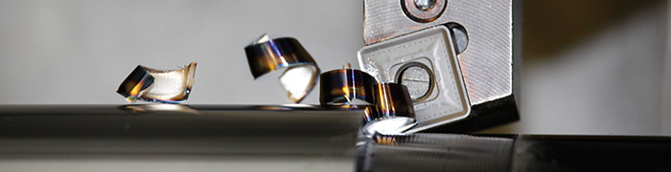
We have launched a new chip breaker and grade for heavy roughing applications.
The HR2 geometry expands our Pramet range of single-sided inserts for machining a wide variety of materials including steels, cast irons and stainless steel.
Designed for rough forgings and castings, such as cylinders, shafts and large pins, the HR2 features a positive, stable geometry for improved tool life and performance.
Its cutting edge design and wide peripheral land promote increased productivity, while offering reliable chip formation and evacuation at high feeds (0.7 mm/rev). This promotes a continuous production process with less machine downtime, resulting in a more cost-effective operation.
The new chip breaker complements our existing HR insert which covers semi-roughing to roughing applications.
HR2 is available with a new turning grade – T9226 – also launched this April.
The versatile T9226 grade achieves impressive results in heavy roughing and peeling operations. For these applications it replaces our existing Pramet 6630 grade.
Providing high insert reliability and durability in adverse cutting conditions, the T9226 offers greater cutting edge strength. This is primarily due to a new functional gradient substrate which contains a higher amount of cobalt binding and finer grain structure.
A special treatment added to the coating's surface promotes reduced adhesion to the workpiece and resistance to the formation of heat-related cracks, resulting in greater operational reliability and longer tool life.

